I consent to take part in the Place Standard Tool. ☐  Demographics  We are committed to ensuring an inclusive sample response and therefore need to collect monitoring data. All data will be kept anonymous.  Postcode: ______________ Town: _______________  Gender: ☐Male ☐Female ☐Transgender ☐Non Binary ☐Prefer not to say  Age: ___________  What is your sexual orientation?  ☐Heterosexual ☐Gay woman/lesbian ☐Gay man ☐ Bisexual  ☐Prefer not to say  If you prefer to use your own term, please specify here ____________________  Which one of these best describes your ethnic group?  ☐ White Scottish☐ Asian Chinese☐ White Other British☐ Asian Scottish/Other  ☐White Irish☐ Black Caribbean☐ White Other☐ Black African  ☐ Mixed Background☐ Black Scottish/Other☐ Asian Pakistani☐ Other  ☐ Asian Bangladeshi☐ Asian Indian ☐ Traveller ☐ Prefer not to say  What is your religion or belief?  ☐ No religion or belief ☐ Buddhist ☐ Christian ☐ Hindu  ☐ Jewish ☐ Muslim ☐ Sikh ☐ Prefer not to say  If other religion or belief, please specify here _________________  Do you consider yourself to be disabled, or have any additional support requirements/health issues that would require support to volunteer?  ☐ Yes☐ No ☐ Prefer not to say  If you wish, please give details _____________________________  Do you have caring responsibilities? If yes, please tick all that apply  ☐ None ☐ Primary carer of a child/children (under 18) ☐ Primary carer of  disabled child/children ☐ Primary carer of disabled adult (18 and over) ☐ Primary carer of older person ☐ Secondary carer (another person carries out the main  caring role) ☐ Prefer not to say | HAVE YOUR SAY IN 5 MINUTES  TO HELP SHAPE AND INFLUENCE ALLOA TOWN CENTRE  Alloa First and Clackmannanshire Council are committed to delivering real improvements to the town centre over the next 5 years and beyond. It is proposed that a Place Plan is developed to guide and inform future actions.  CTSI are supporting and training communities across Clackmannanshire to carry out this research. We now need your help to inform the plan, and ensure we know what needs done to make Alloa a more pleasant and enjoyable place to live, work, shop and visit.  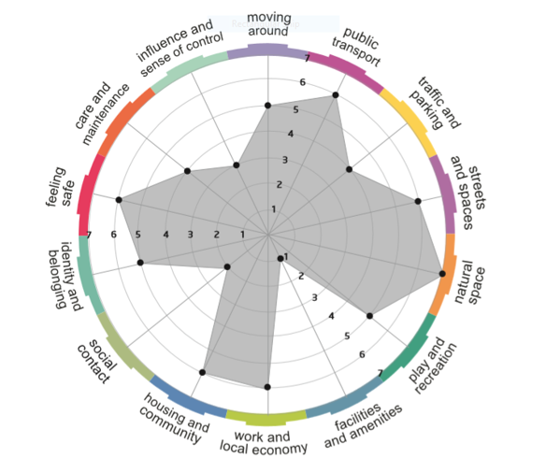  The Scottish Government’s Planning & Architecture  PLACE STANDARD TOOL  Simply plot your opinions on the scale within. For the full questionnaire please visit https://www.surveymonkey.co.uk/r/BHRHPZR

Please use the below tool to rate Alloa Town Centre on a scale from 1 to 7, according to the 14 areas set out opposite.  1 = there is a lot of room for improvement  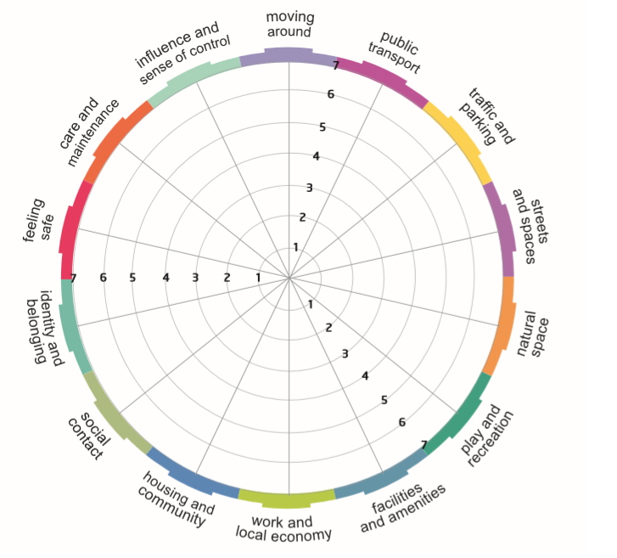  7 = there is very little room for improvement  If you have any further comments, please use the space provided below or contact Danny to arrange a 1:1 chat on 01259 213 840 or danny.fenton@ctsi.org.uk | Moving around  Can I easily walk and cycle around using good-quality routes?  Public Transport  Does public transport meet my needs?  Traffic and parking  Do traffic and parking arrangements allow people to move around safely and meet the community’s needs?  Streets and spaces  Do buildings, streets and public spaces create an attractive place that is easy to get around?  Natural space  Can I regularly experience good-quality natural space?  Play and recreation  Can I can access a range of space with opportunities for play and recreation?  Facilities and amenities  Do facilities and amenities meet my needs?  Work and local economy  Is there an active local economy and the opportunity to access good-quality work?  Housing and community  Do the homes in my area support the needs of the community?  Social contact  Is there a range of spaces and opportunities to meet people?  Identity and belonging  Does this place have a positive identity and do I feel I belong?  Feeling safe  Do I feel safe here?  Care and maintenance  Are buildings and spaces well cared for?  Influence and sense of control  Do I feel able to take part in decisions and help change things for the better?

